Sequence Diagrams
System Interaction Flows
May 2026

1. Language Switch Flow
This diagram illustrates the sequence of interactions when a user switches the application language. The LanguageContext persists the preference to localStorage and triggers a re-render of all page components with the updated direction and locale.
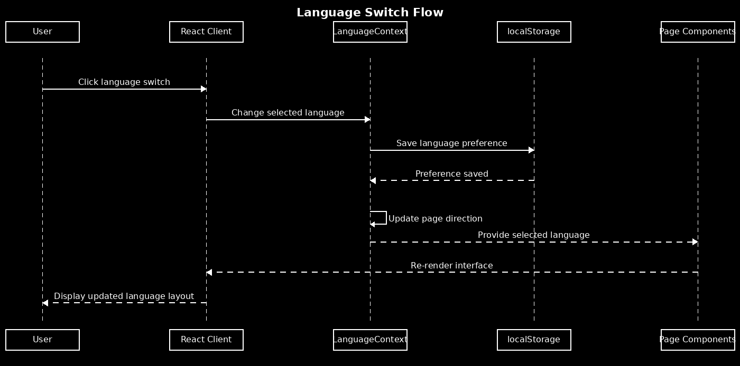

2. Checkout Flow
This diagram illustrates the e-commerce checkout process. The React Client coordinates with CartContext and the Express Server, which verifies the JWT token, validates product availability in the SQLite database, creates the order, and updates stock before returning a confirmation.
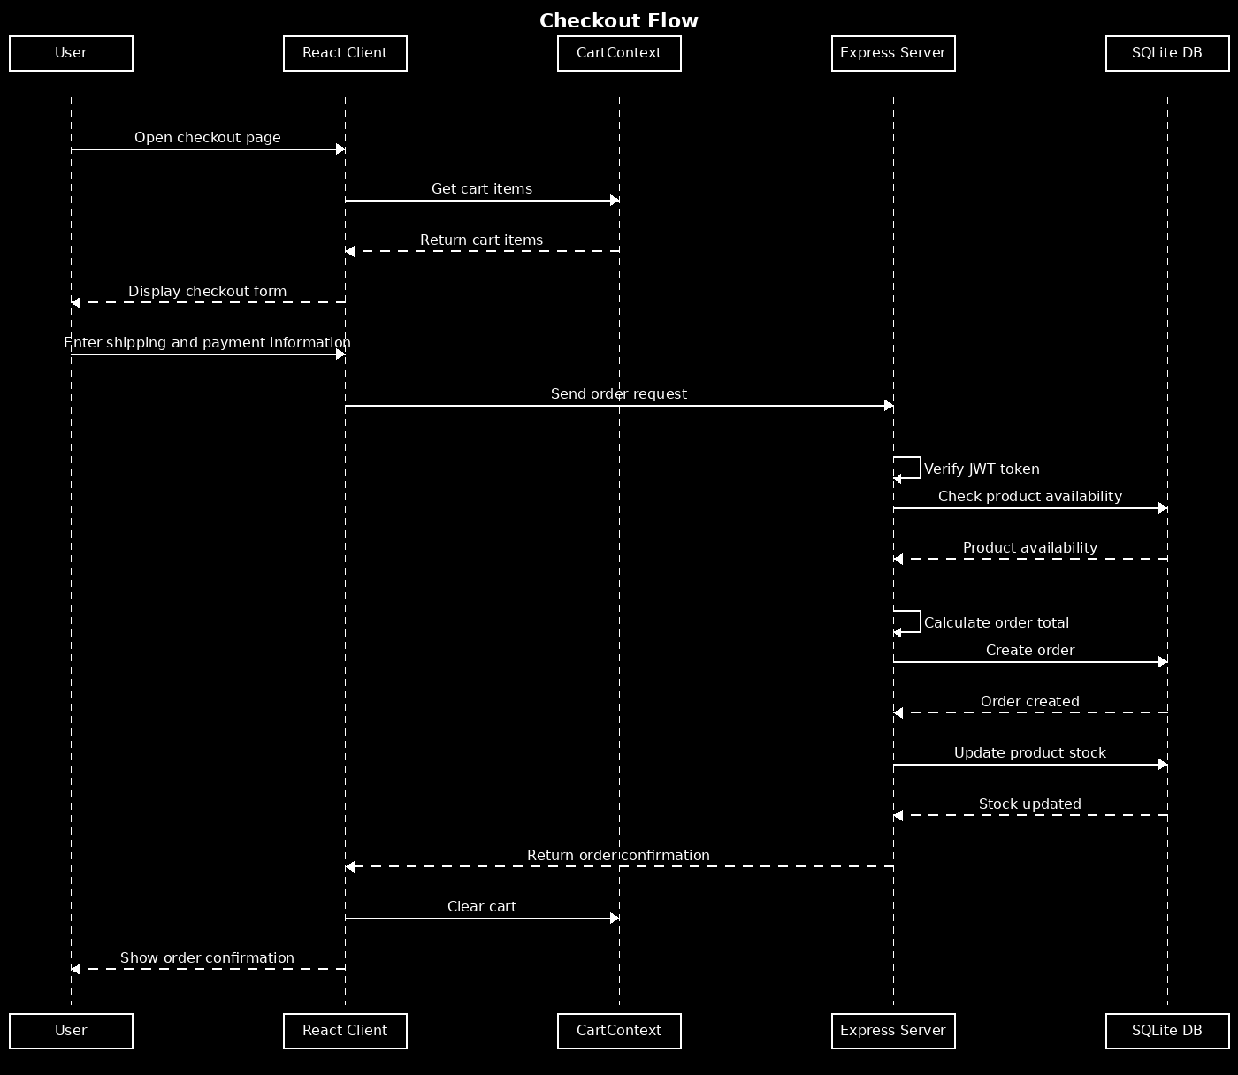

3. Login / Logout Flow
This diagram shows the authentication lifecycle. On login, the Express Server validates credentials against the SQLite database, signs a JWT token, and returns it to the React Client for storage. On logout, the server endpoint is called and the token is cleared from the client.
